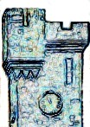 Ayton Local History Society

Ayton shops and businesses in the past

Please let us have any additional information you have
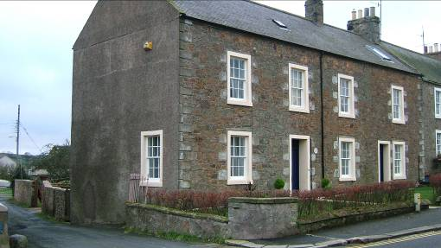
Business Name Dates
Sawmill Jock Hearn
Hearn & Hogg
Inglis & Hogg

Notes

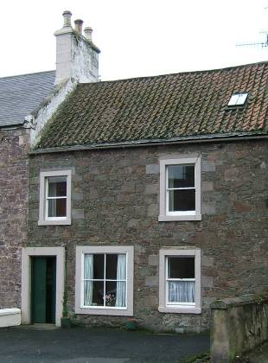
Business Name Dates
Plumber Alex & John Christie
Alex Christie

Notes
John set up independently further down street

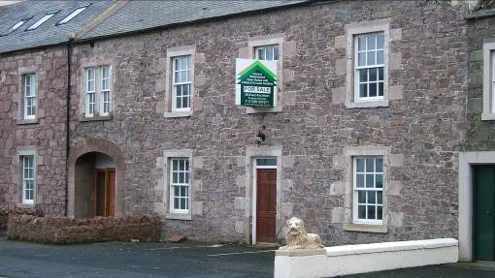
Business Name Dates
Private House

Notes
Incorporated into enlarged Red Lion by Watkinsons?

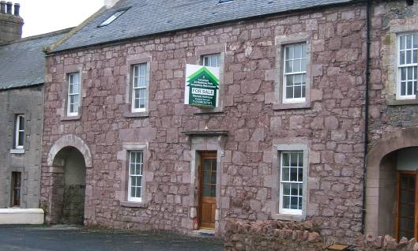
Business Name Dates
Red Lion Hotel Jessie Walker

Notes

X

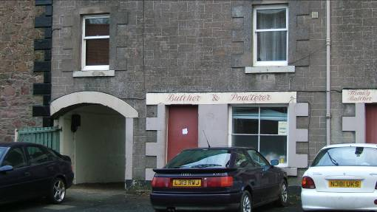
Business Name Dates
Butcher Jock Whyte

Notes

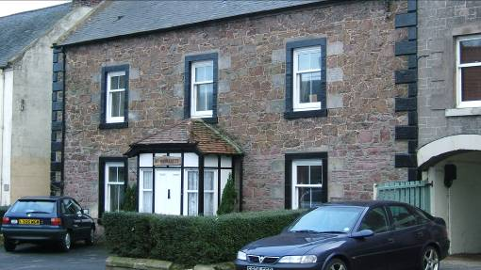
Business Name Dates
Post Office Sinclair

Notes

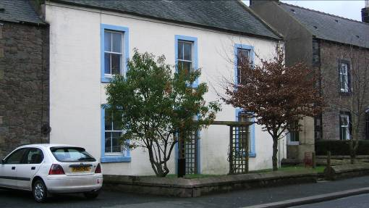
Business Name Dates
School Master’s
House

Notes

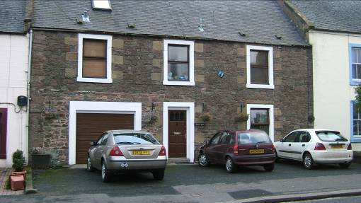

Business Name Dates
Tailor Dalgetty
Gillies

Notes

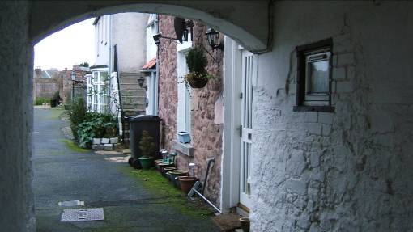
Business Name Dates
Dairy

Notes

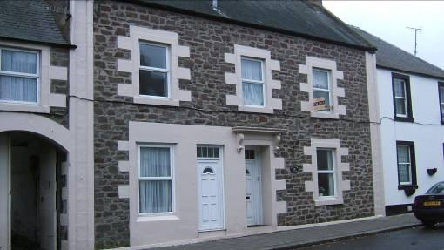
Business Name Dates
Baker Craig
Baker Anderson

Notes

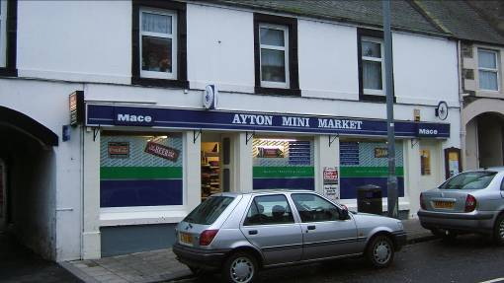
Business Name Dates
Blacksmith
Garage & Shop Wood

Notes

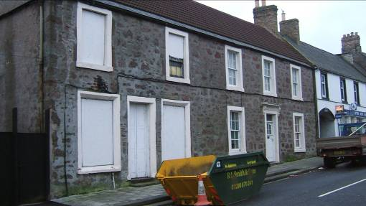
Business Name Dates
Plumber John Christie

Notes
Lemonade factory somewhere in this area

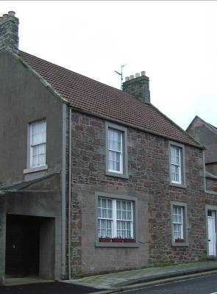
Business Name Dates
Saddler Joe Cooper

Notes
This was an “Alladin’s Cave” selling all sorts of things (including tea sets, paraffin, hardware etc)

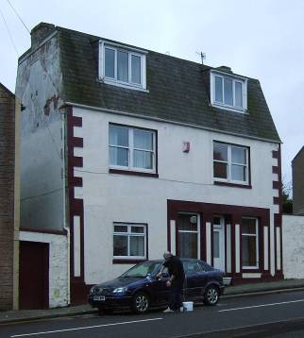
Business Name Dates
Fancy goods Miss JB Hume

Chip shop closed late 1980s

Notes

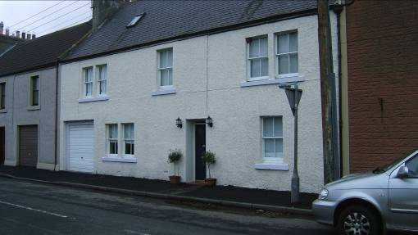
Business Name Dates
Hair cutting Peter Lugton
Hat maker Miss Lizzie Watt

Notes
Lizzie Watt was housekeeper to Peter Lugton

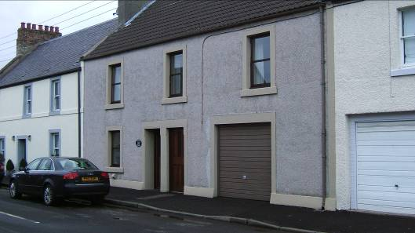
Business Name Dates
Game dealer Spratt

Notes
Tannery at some time?

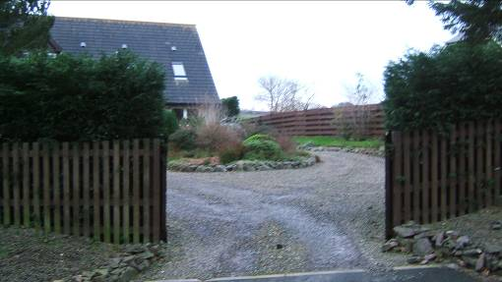
Business Name Dates
Nursery Archie Morrison
Nursery Nichol

Notes
supplied veg, tomatoes, cut flowers etc

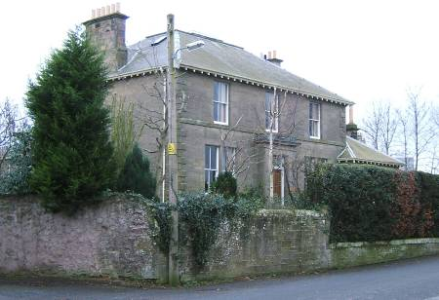
Business Name Dates
Bank Royal Bank of Scotland

Notes

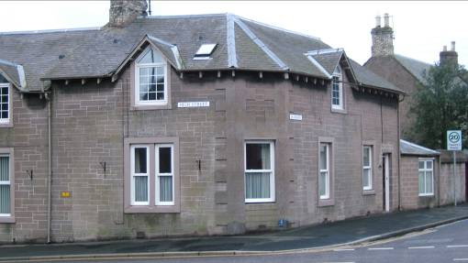
Business Name Dates
Post Office Inglis
Post Office Skinner
Post Office Mrs Young

Notes
Telephone exchange was here before it was automated

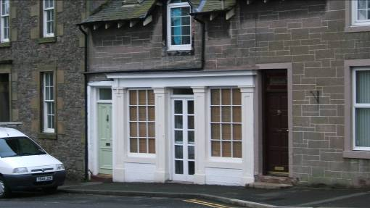
Business Name Dates
Sweet shop Annie Hume
Newspapers Dixons
Mrs Darling

Notes

Business Name Dates
Misses Spence

Notes
Cows were kept in a byre behind Moffat House and milk could be bought here.

Moffat house

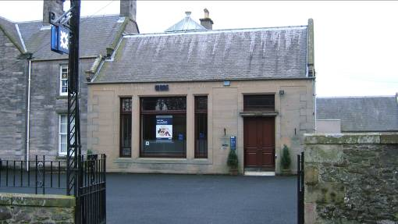
Business Name Dates
Bank Commercial Bank

Notes

Photo to follow
Business Name Dates
Solicitors Doughty’s

Notes

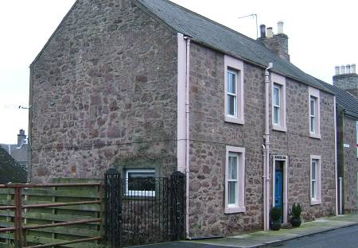
Business Name Dates
Blacksmith Weddell

Notes

Business Name Dates
Sweet shop Andrew Phillips

Notes
Andrew Phillips acted as agent for parcels delivered by bus

Next to Volunteer Hall

Business Name Dates
Grocer Sinclair
Grocer Stoddart

Notes
No 2 Oldtown photo to follow

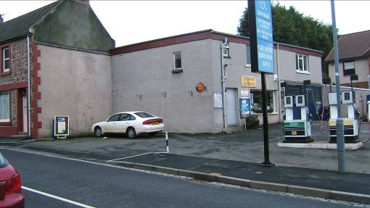
Business Name Dates
Bicycle repair Willie Hall
Batteries etc
Business Name Dates
Store for Stoddarts (Grocer) farther down the street.
Antiques Mr Bamford

Notes

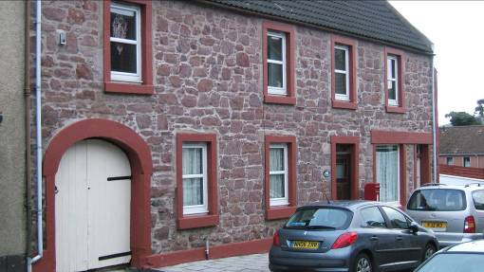
Business Name Dates
Baker Armitage
Baker Dalgleish

Notes

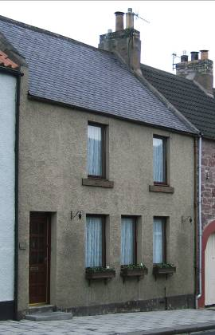
Business Name Dates
Sweetie Shop Jenny Gummy’s

Store for Woods (across the street)

Notes

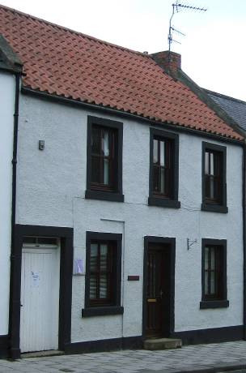
Business Name Dates

Notes

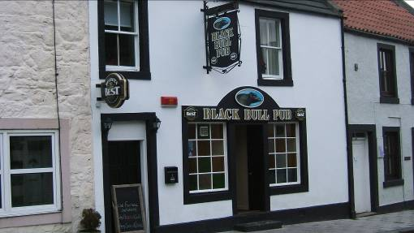
Business Name Dates
Black Bull

Notes

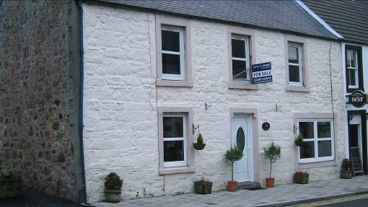
Business Name Dates
Bicycle Shop Whitehead

Baby clothes Mrs Whitehead

Notes
Mrs Whitehead had the baby clothes shop when her husband died.

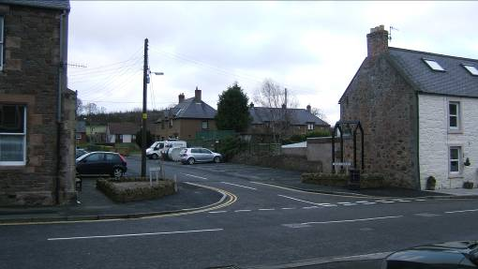
Business Name Dates
White Swan
Hotel

Butcher?

Notes
Demolished to provide access to Crofts

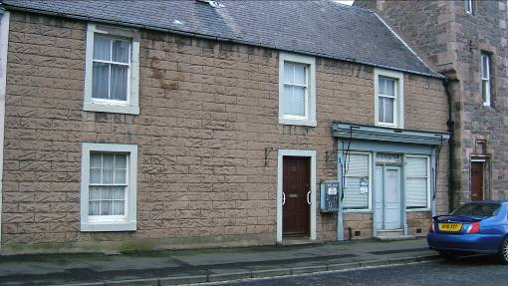
Business Name Dates
Grocer Johnston

Grocer Bobby Gilchrist closed 1990s

Notes
Several generations of the Johnston family ran this business

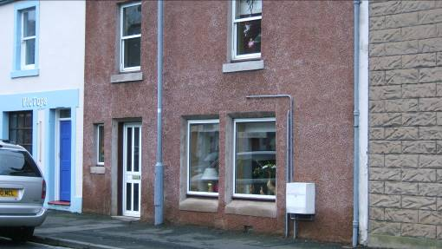
Business Name Dates
Shoe Shop Gilbert Burn

Notes
Gilbert Burn was also a postman

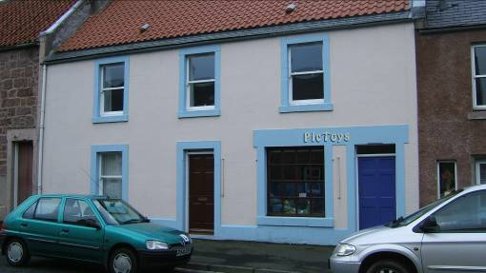
Business Name Dates
Newsagent Mrs Jeffery
& Confectioner

Notes

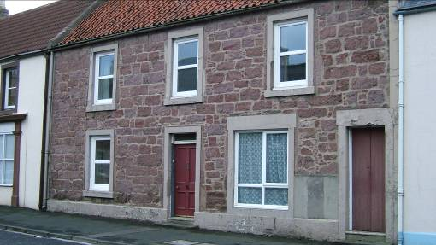
Business Name Dates
Shoe Shop Miss Allan

Electrician Learmonth

Post Office Isobel Calder

Notes

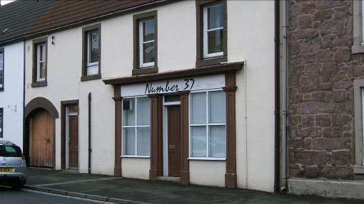
Business Name Dates
Draper & Mason closed late 1970s
Milliners

Notes
Alex Mason was the last of the family to run the business
Other information from June Buchan:

Dunclutha: Vet Ainsworth Wilson

Colville House: Doctors. Dr Edgecombe

Old Town (first arch): Abbatoir

